# Excel Assignment - 8

1. What do you mean by AutoComplete feature in Excel and what are the benefits of using this feature?

Ans: The AutoComplete feature is a tool that helps you enter data more quickly and accurately by suggesting possible completions for the data you are typing.

For example, if you have a list of names in a worksheet and you begin typing a name in a cell, Excel will automatically display a list of names that match the letters you have typed so far. You can then select the correct name from the list by using the arrow keys or mouse, or you can continue typing to narrow down the list of suggestions.

There are several benefits to using the AutoComplete feature in Excel:

• It can save you time and effort by eliminating the need to type out long or complex entries manually.

• It can help you avoid typos and spelling mistakes, which can lead to errors in your data.

• It can help you ensure that your data is consistent and accurate by suggesting possible completions based on the data that you have already entered.

• It can make it easier to enter data into a worksheet by providing suggestions as you type, rather than requiring you to remember the exact spelling or formatting of an entry.

1. Explain working with workbooks and working with cells.

Ans: A workbook is a file that contains one or more worksheets, which are used to organize and store data. Each worksheet consists of a grid of rows and columns, and each cell in the grid can contain a piece of data, such as a number, text, or a formula.

To work with workbooks in Excel:

* Open a workbook: You can open an existing workbook by double-clicking on its file name in the File Explorer window, or by selecting it from the "Recent" list in the Excel start screen.
* Create a new workbook: You can create a new, blank workbook by clicking on the "New" button in the Excel start screen, or by selecting "New" from the "File" menu.
* Save a workbook: You can save a workbook by clicking on the "Save" button in the "Quick Access Toolbar" at the top of the Excel window, or by selecting "Save" from the "File" menu.

To work with cells in Excel:

* Select cells: You can select a single cell by clicking on it, or you can select a range of cells by clicking and dragging over them. You can also use the "Shift" and "Ctrl" keys to select multiple cells or ranges of cells.
* Enter data into cells: You can enter data into a cell by clicking on it and typing the data you want to enter. You can also use the "Copy" and "Paste" commands to copy data from one cell or range of cells and paste it into another.

Format cells: You can format cells by selecting them and using the formatting options in the "Home" tab of the ribbon. For example, you can change the font, size, and color of the text in a cell, or you can apply borders or shading to the cell.

1. What is fill handle in Excel and why do we use it?

Ans: the fill handle is a small black square that appears in the bottom-right corner of a selected cell or range of cells. It is used to quickly copy or fill data into adjacent cells.To use the fill handle, you can click and drag it to select the range of cells that you want to fill. As you drag the fill handle, Excel will automatically display a preview of the data that will be copied or filled into the selected cells. You can then release the mouse button to apply the fill.

There are several reasons why you might want to use the fill handle in Excel:

• To quickly copy data: You can use the fill handle to copy data from one cell or range of cells and paste it into another. This can save you time and effort if you need to enter the same data into multiple cells or worksheets.

• To fill series of data: You can use the fill handle to quickly fill a series of cells with a pattern of data, such as a series of numbers, dates, or text.

• To apply formatting: You can use the fill handle to apply formatting, such as font, size, or colour, to a range of cells.

• To apply formulas: You can use the fill handle to apply a formula to a range of cells. For example, you can use the fill handle to apply a formula that multiplies two cells together to a range of cells.

1. Give some examples of using the fill handle.

• Copying data: Suppose you have a list of names in cells A1 to A10, and you want to copy that list to cells B1 to B10. To do this, you can select cells A1 to A10, click and drag the fill handle to cells B1 to B10, and then release the mouse button. This will copy the data from cells A1 to A10 to cells B1 to B10.

• Filling a series of numbers: Suppose you want to fill a range of cells with a series of numbers, such as 1, 2, 3, 4, etc. To do this, you can enter the number 1 into the first cell of the range, and then select that cell and the cells below it. Next, you can click and drag the fill handle down the column, and Excel will automatically fill the selected cells with the series of numbers.

1. Describe flash fill and what the different ways to access the flash fill are.

Ans: Flash Fill is a feature in Microsoft Excel that helps you quickly and easily extract, rearrange, or combine data in a worksheet. It is especially useful when you have a large amount of data and you want to extract or rearrange specific pieces of information.

There are several ways to access the Flash Fill feature in Excel:

• Using the Flash Fill button: In the "Data" tab of the ribbon, you can find the "Flash Fill" button in the "Data Tools" group. You can click on this button to automatically fill cells with data that matches the pattern you have typed into other cells.

• Using the keyboard shortcut: You can also use the keyboard shortcut "Ctrl + E" to access the Flash Fill feature.

• Using the "Ctrl + Enter" shortcut: If you have typed the data that you want to extract or rearrange into a cell, you can use the "Ctrl + Enter" shortcut to fill the selected cell and all the cells below it with the data that matches the pattern you have typed.

• Using the AutoComplete feature: As you type data into a cell, Excel will automatically display a list of possible completions for the data you are entering. You can use the arrow keys or mouse to select a completion from the list, or you can continue typing to narrow down the list of suggestions.

6. Extract first name and last name from the mail id and then from the address column, extract the city, state, and pin code using the flash fill.

Given below is an example of the columns you have to create. Paste the screenshot of what you have created using the flash fill command. Example: Mail Id, Address, First name, Last name, State, City, Pincode

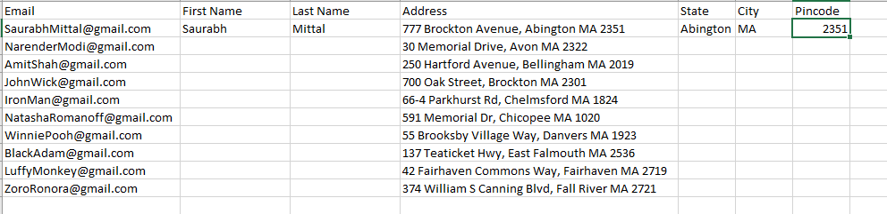

Now either you can do “Ctrl + E” or go to Data → Flash Fill



